**PRACTICAL NO.2**

**Creating and Managing Vector Data: Adding vector layers, setting properties, formatting,**

**calculating line lengths and statistics**

**Creating and Managing Vector Data**

Select Layer > New Shapefile Layer > 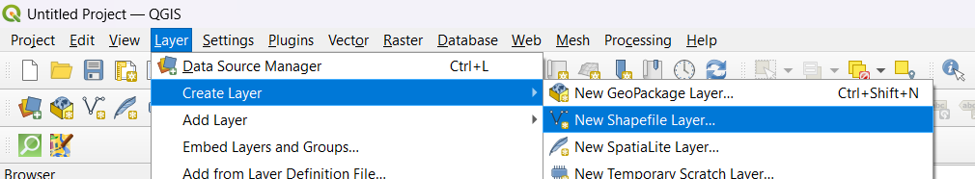

Set File name : kudal.shp > Geometry type : Polygon > Add Minimum 2 Field List : id,name > Ok >

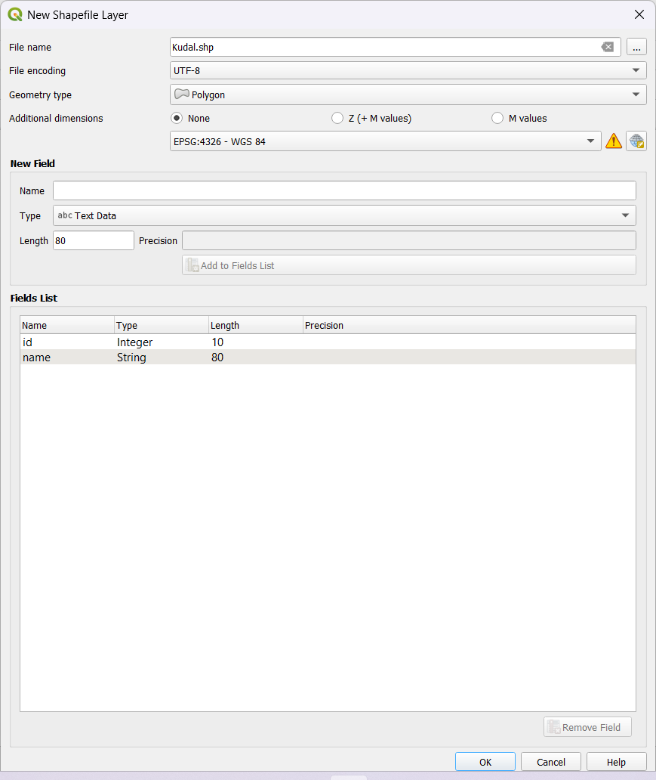

Output after adding Polygon Shapefile Layer >

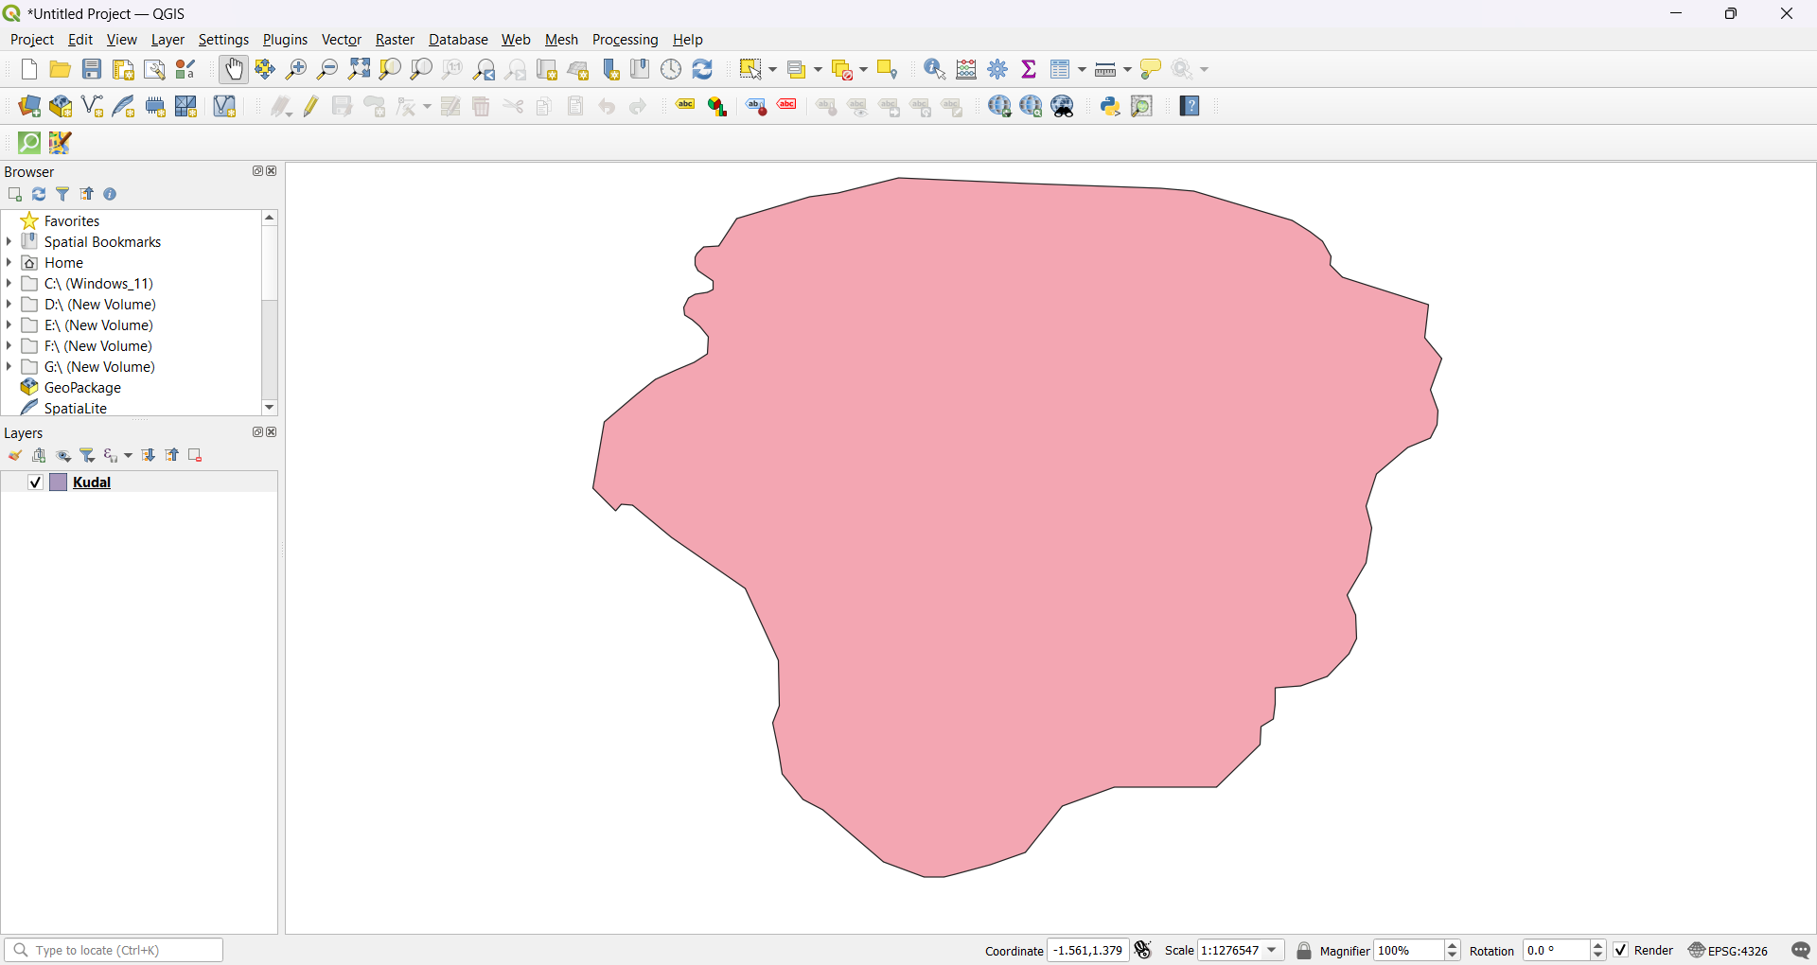

Right click on Added Layer > Properties >

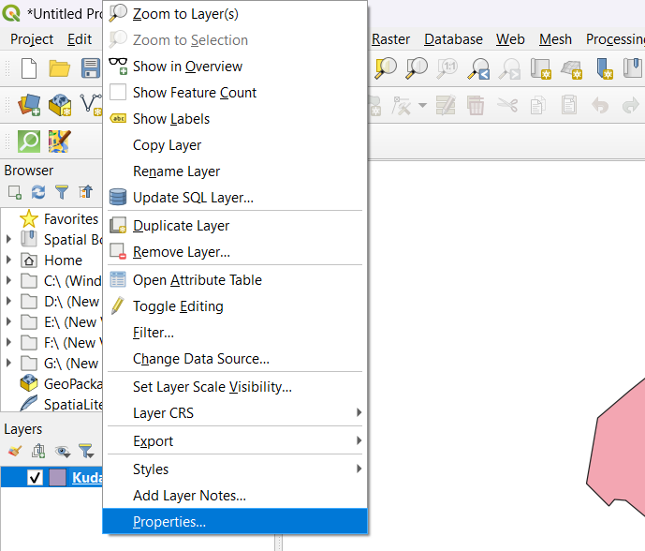

Layer Properties > Symbology : Set Color > Apply >

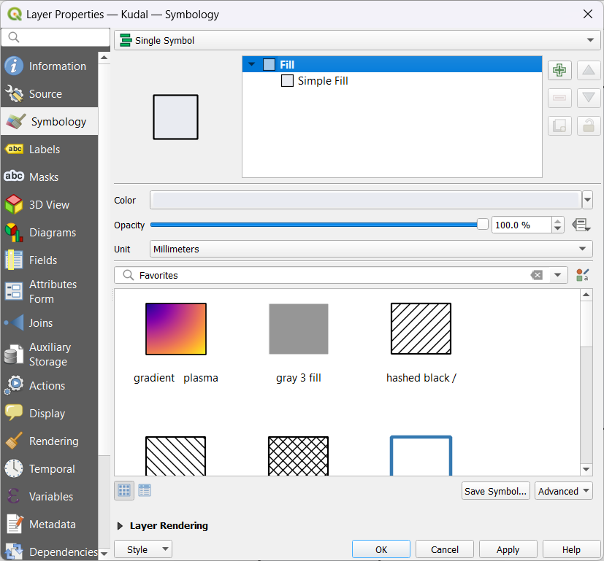

Layer Properties > Labels :Single Labels > Apply >

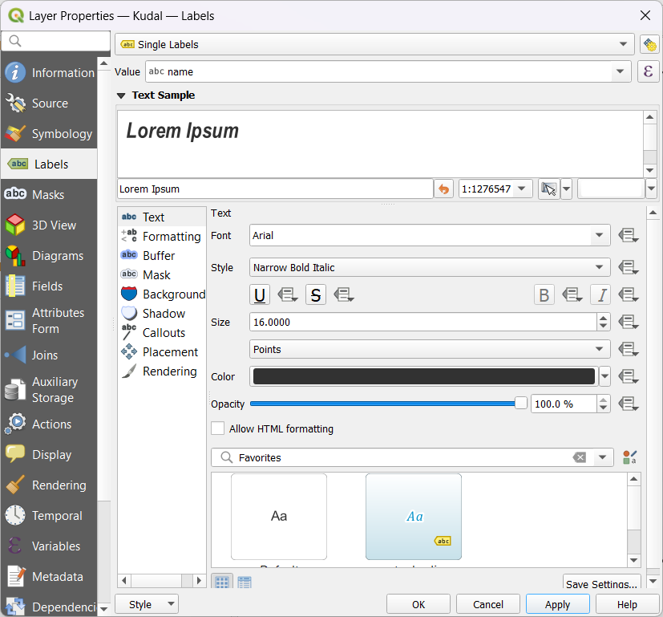

Output After Setting Properties > 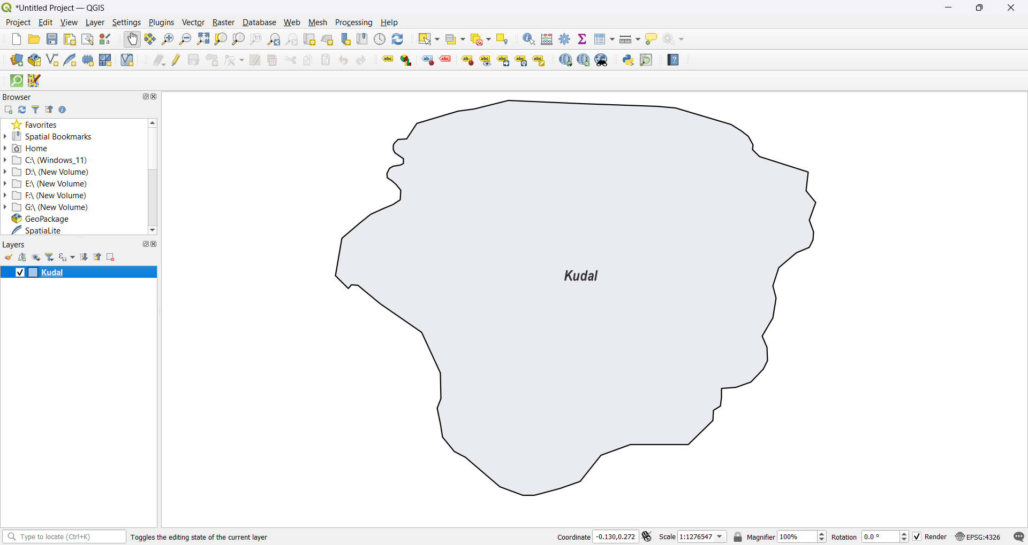

Output after adding Polygon Shapefile Layers : Buildings , Bank, Hospitals, Gardens > 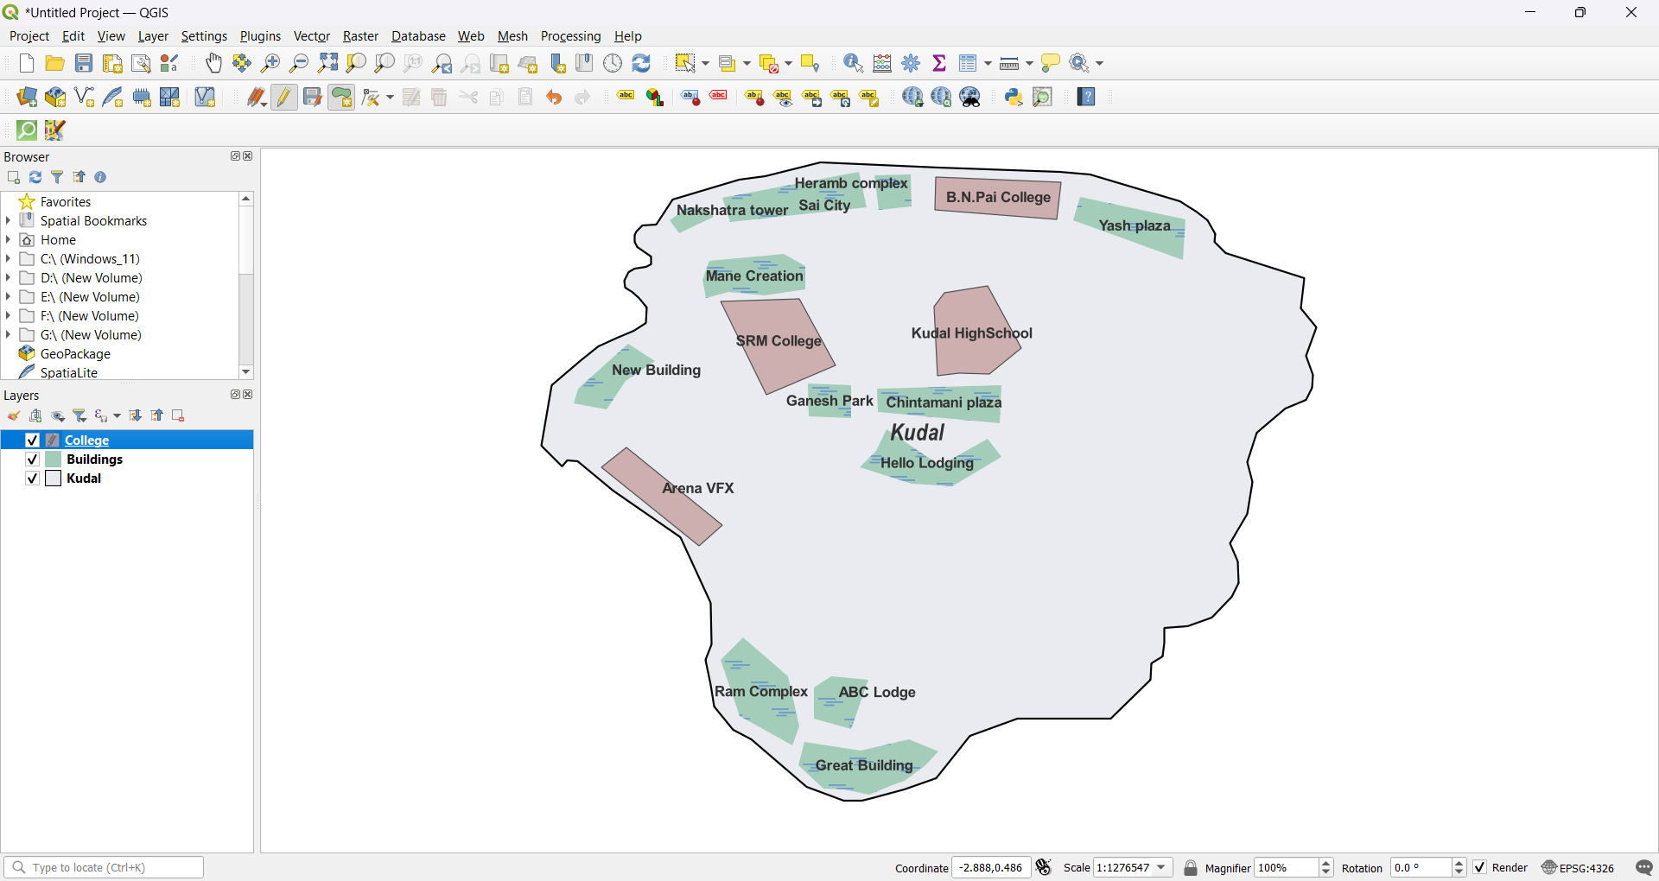

Set File name : Ground.shp > Geometry type : Point > Add Minimum 2 Field List : id,name > Ok >

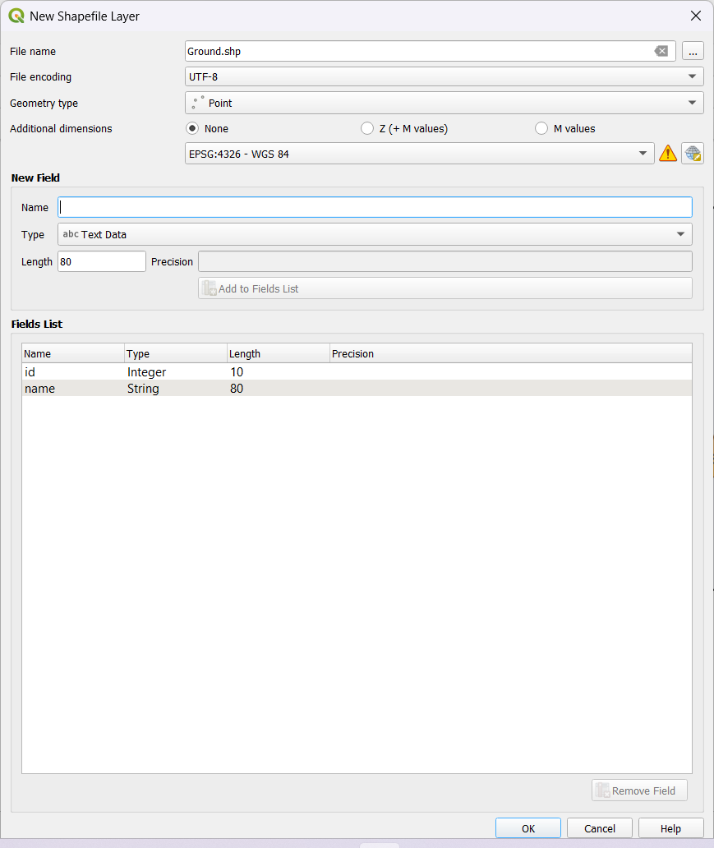

Output after adding Point Shapefile Layer >

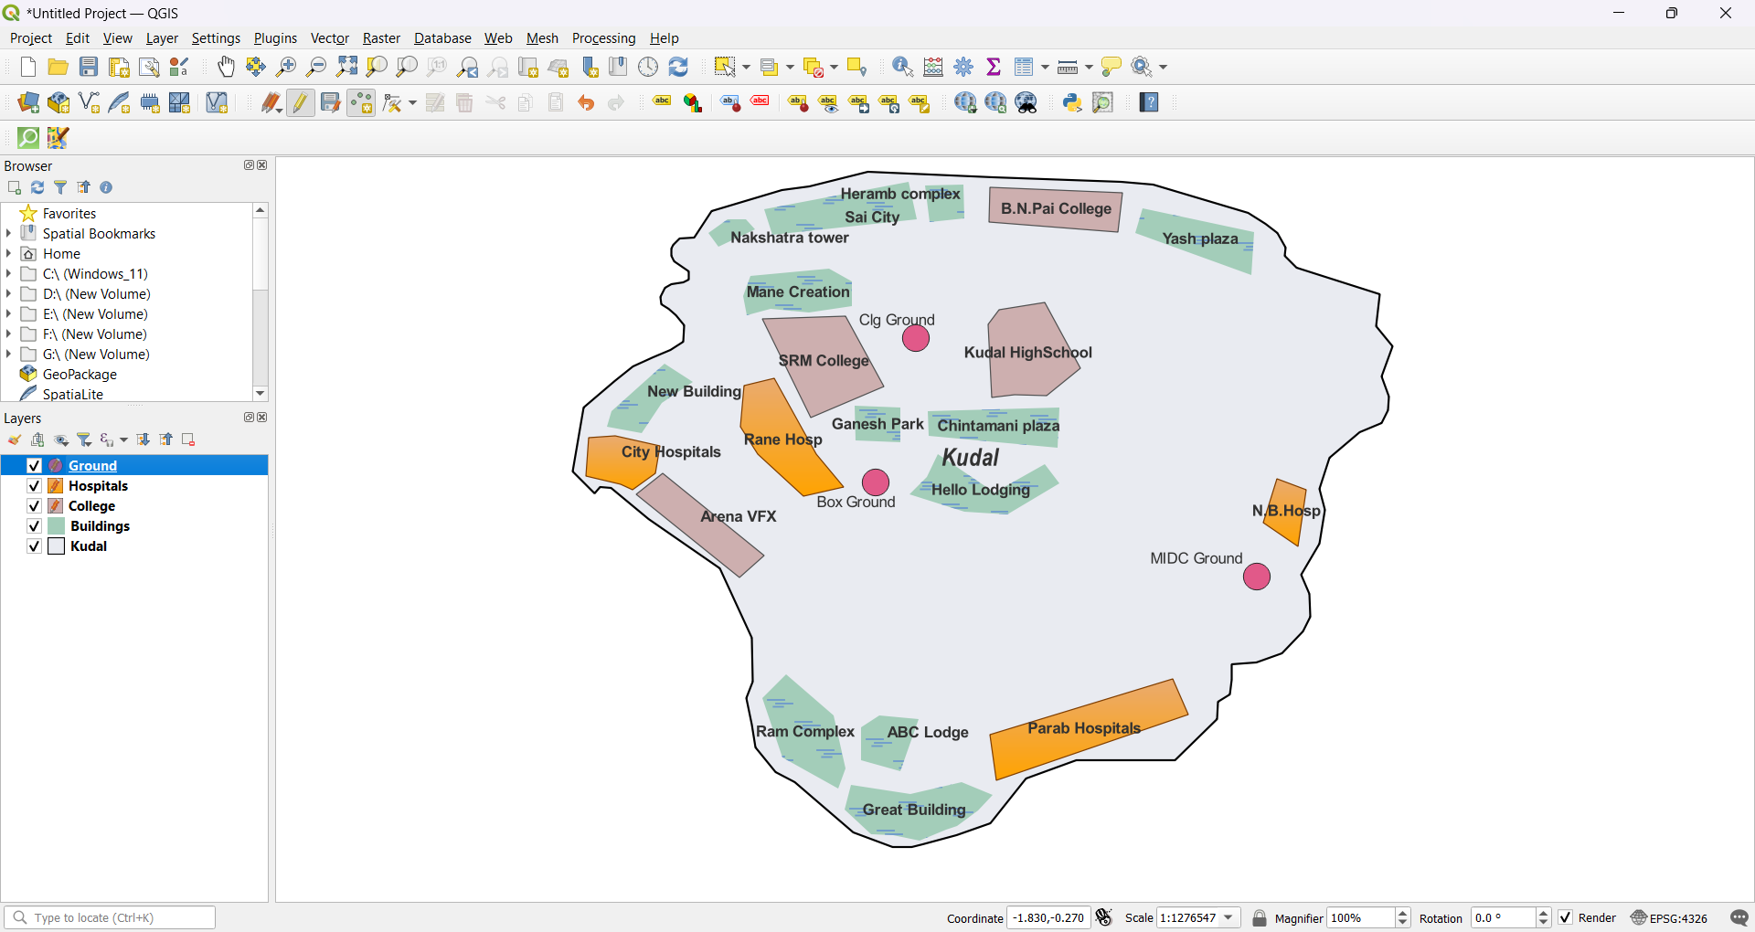

Set File name : Roads.shp > Geometry type : LineString > Add Minimum 2 Field List : id,name > Ok >

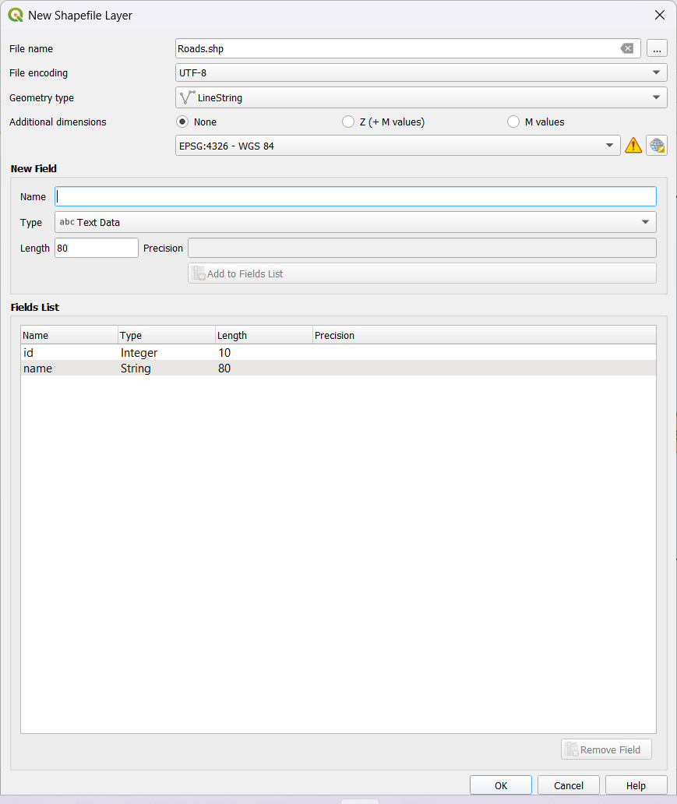

Output after adding LineString Shapefile Layer >

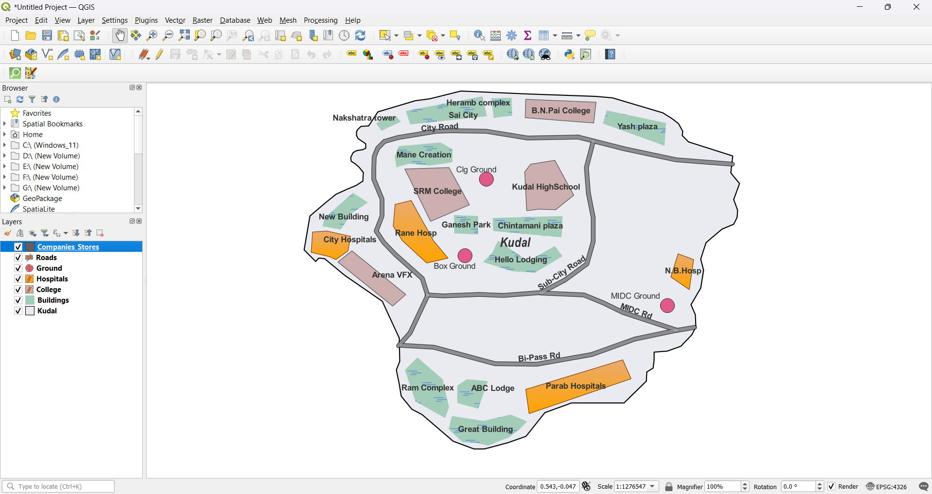

Final Output after adding all Polygon ,Point and LineString Shapefile Layers >

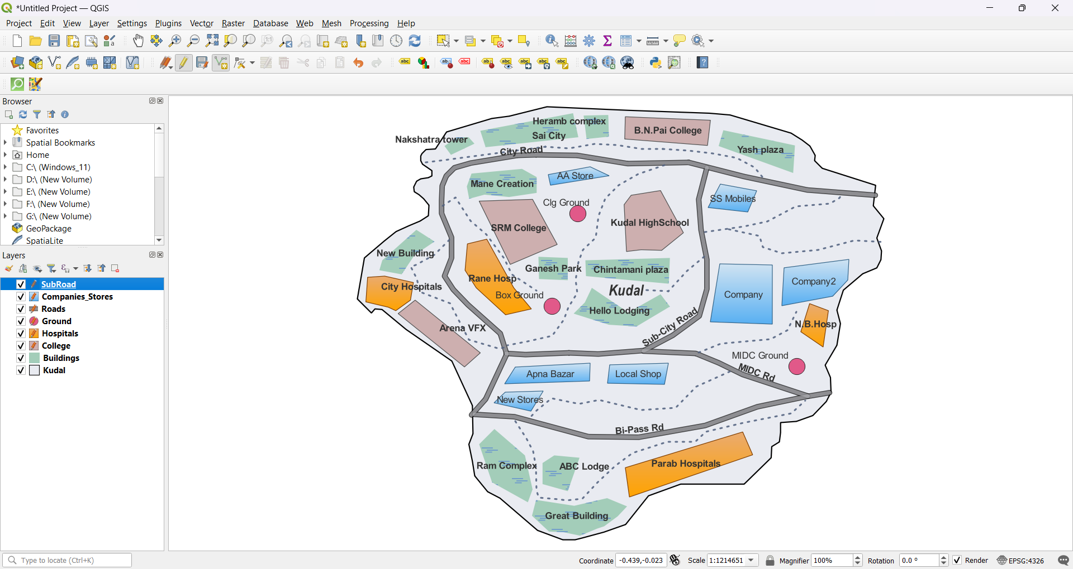

**Adding vector layers:**

Add layer > Add Vector Layer

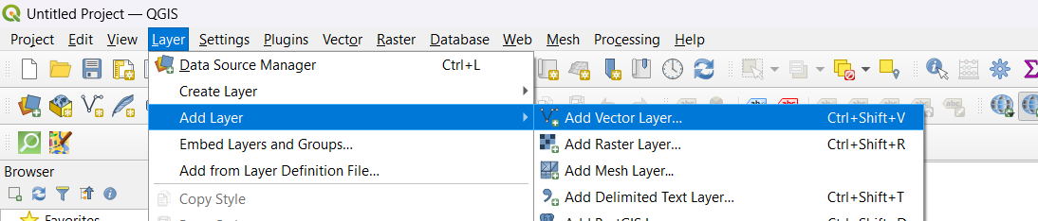

Select Vector > Browse Vector Database > IND_adm.zip > Add >

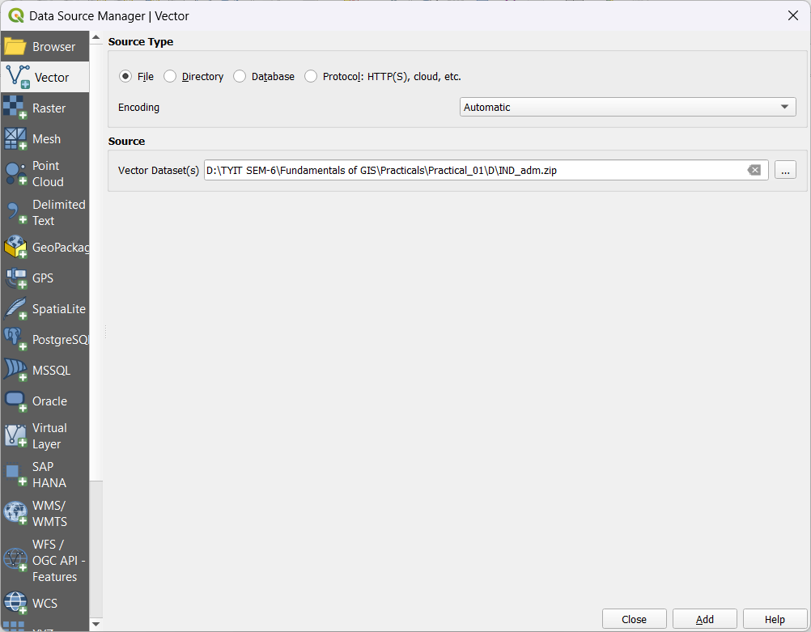

Select IND_adm0.shp > Click Add Layers

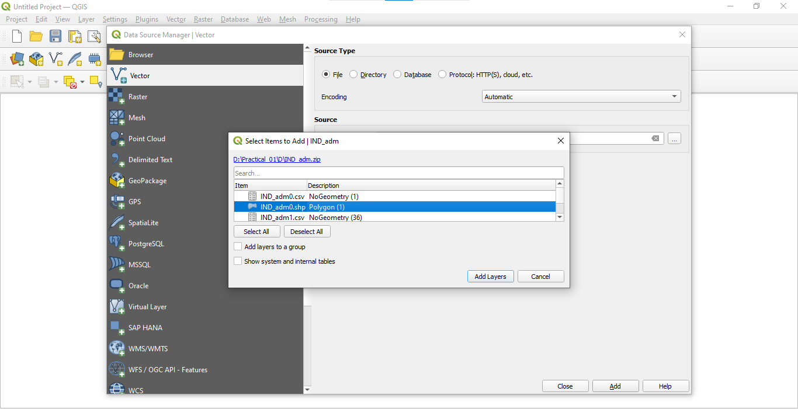

Output after adding IND_adm0.shp >

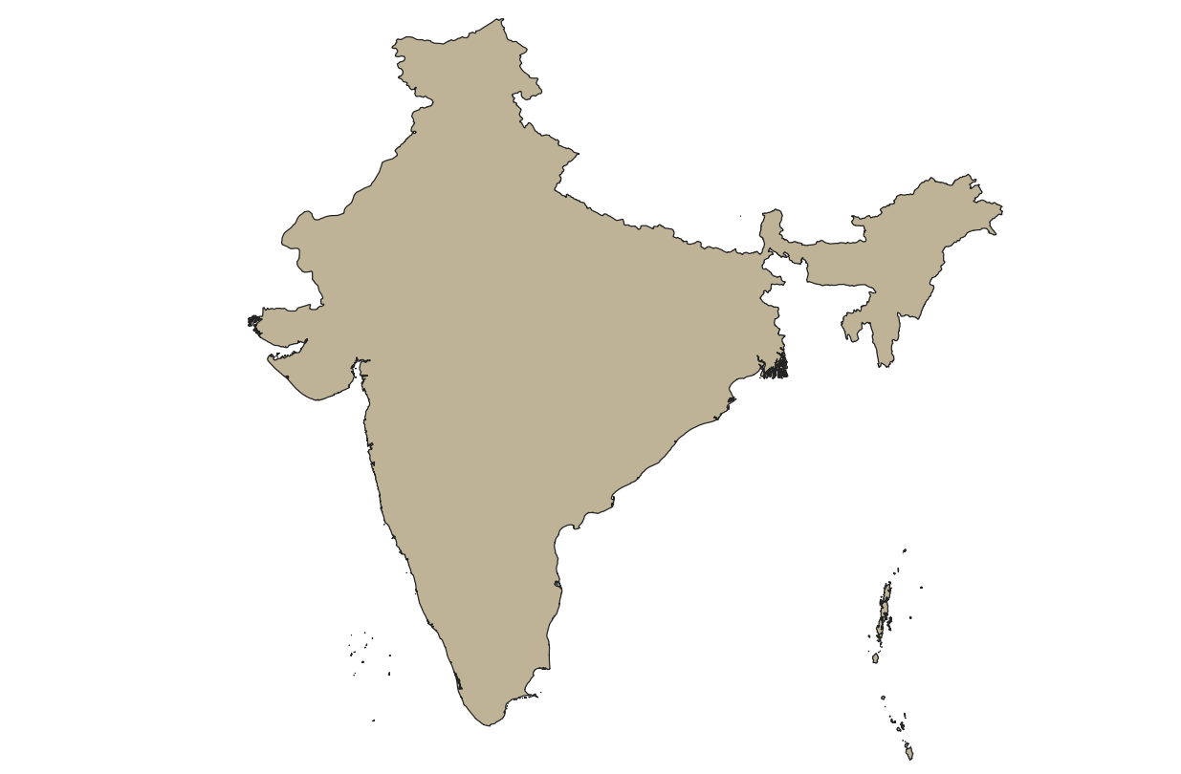

**Setting properties:**

Right Click on IND adm0.shp layer > Properties >

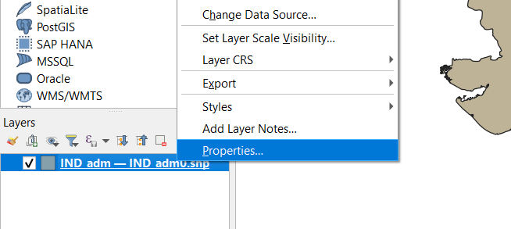

Go to Symbology > select color(Outline blue) > Apply >

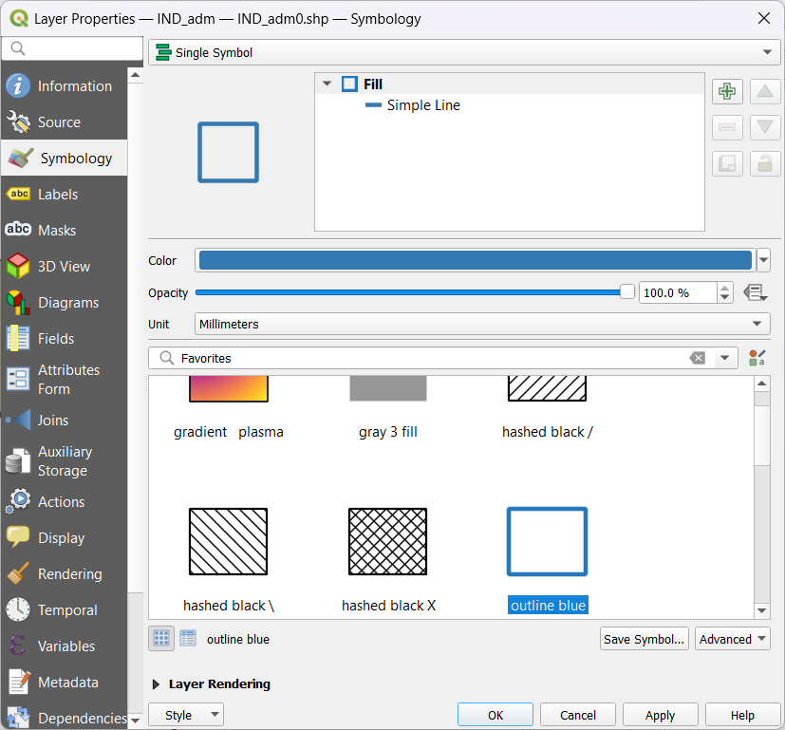

Output after setting color properties >

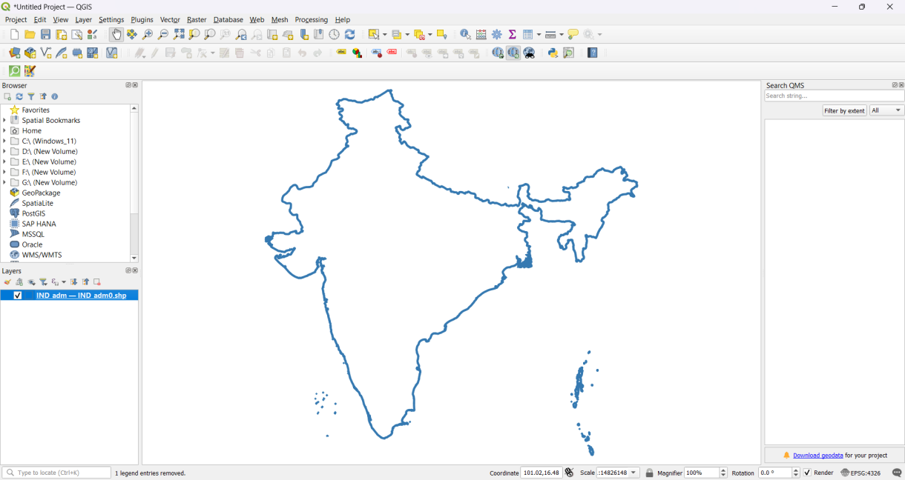

**Formatting and calculating line lengths and statistics:**

Add layer > Add Vector Layer > Browse Vector Database > IND_rrd.zip > Add >

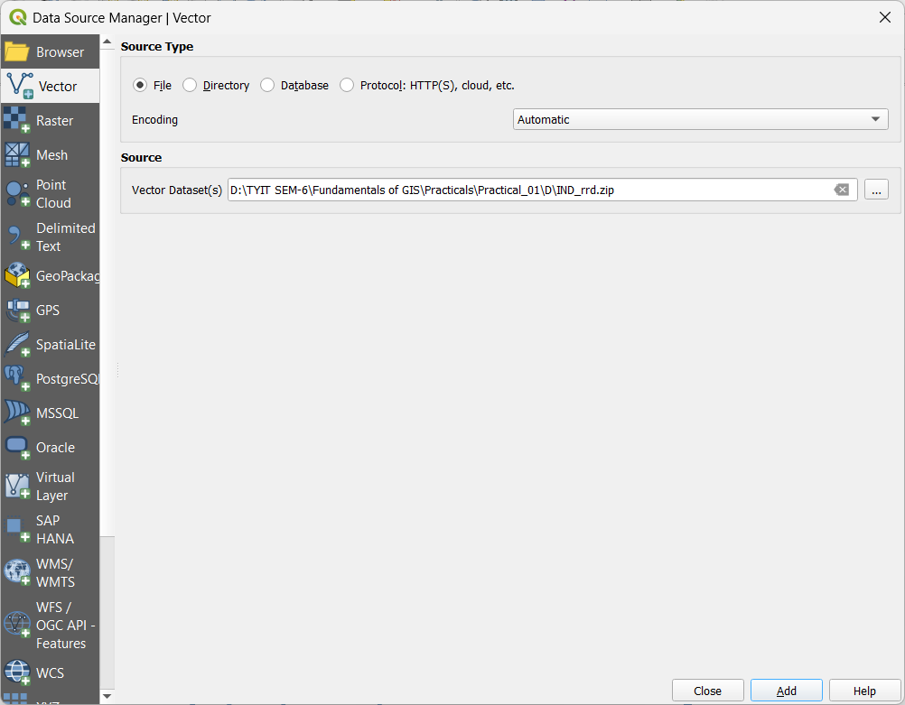

Output after adding IND_rrd >

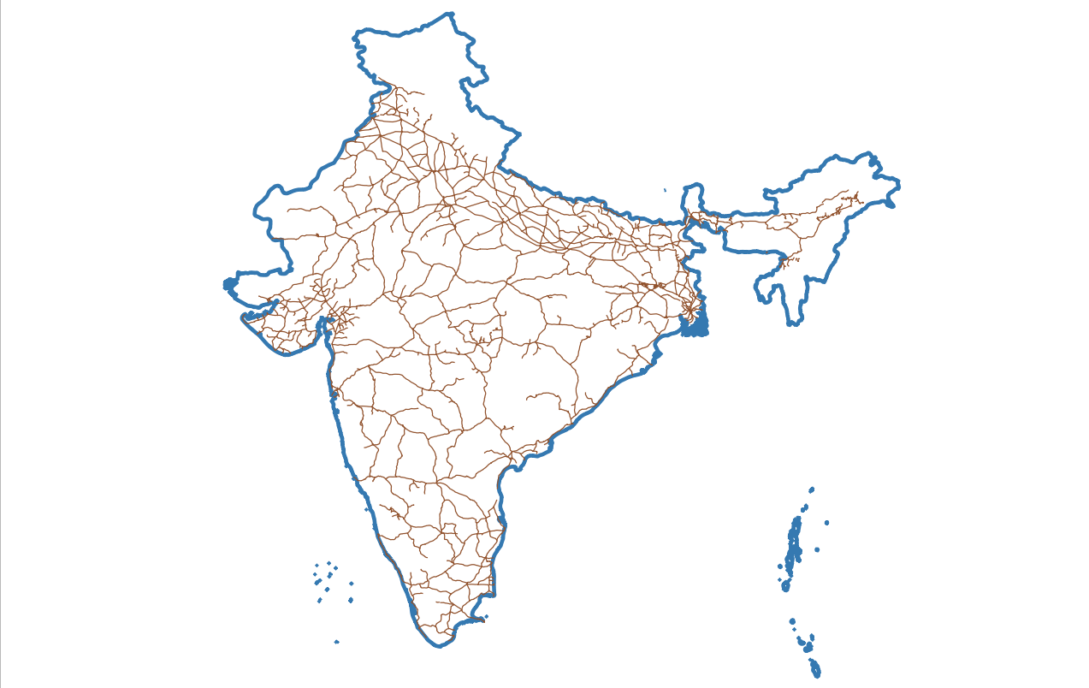

Right click on IND rails.shp layer > Open Attribute Table >

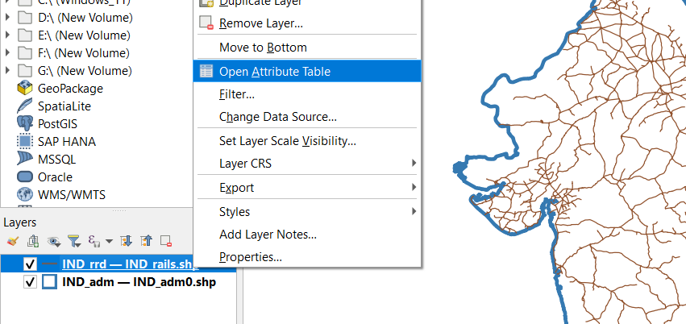

Attribute Table of IND_rails.shp >

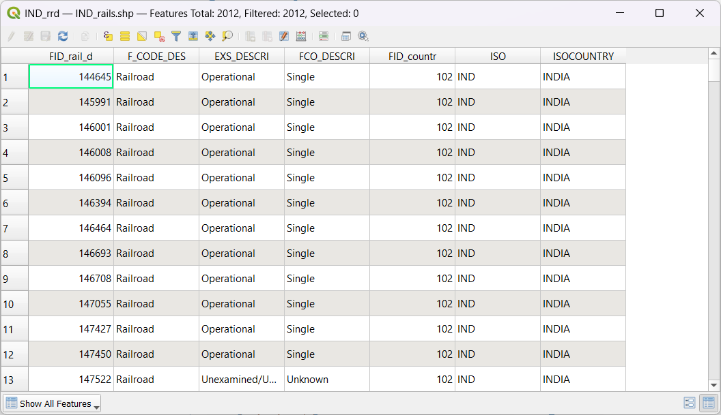

At attribute table > Open field Calculator > Set Output field name : Trak_len> Set Output field type : Decimal number > Set expression : $length / 1000 > ok

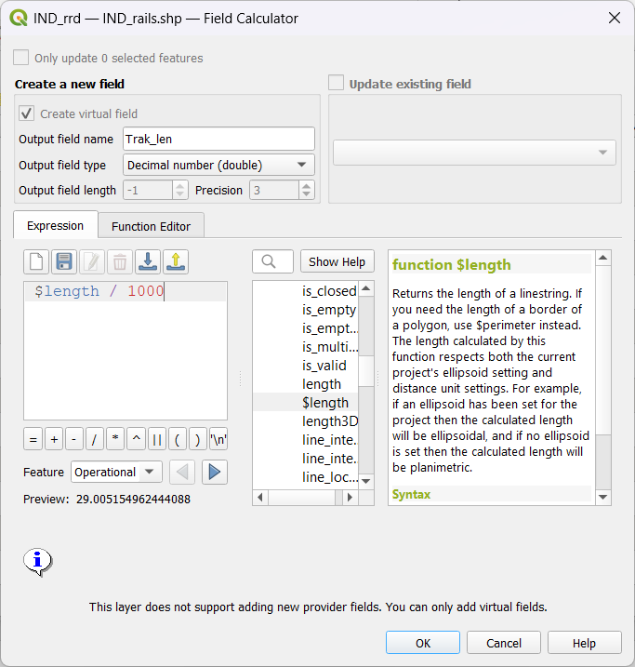

Attribute table after adding Trak_len field >

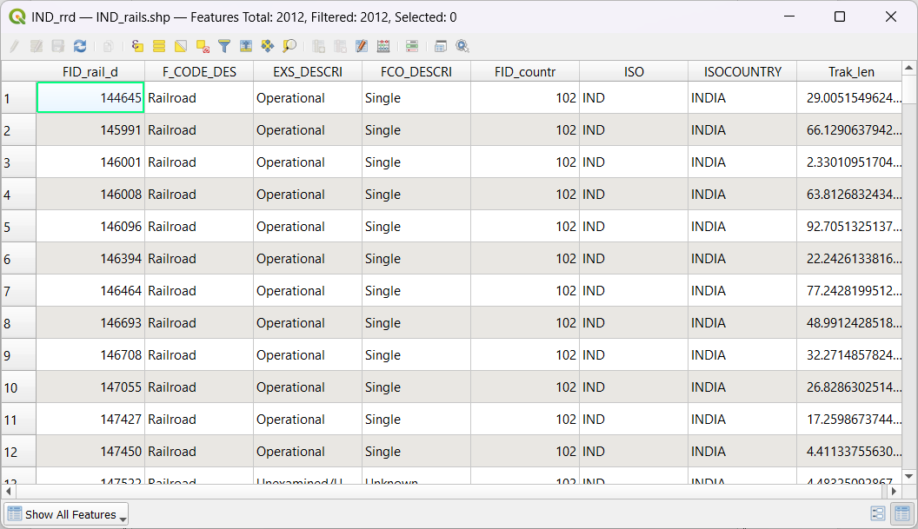

Select Vector > Analysis Tools > Basic Statistics for fields.. > click

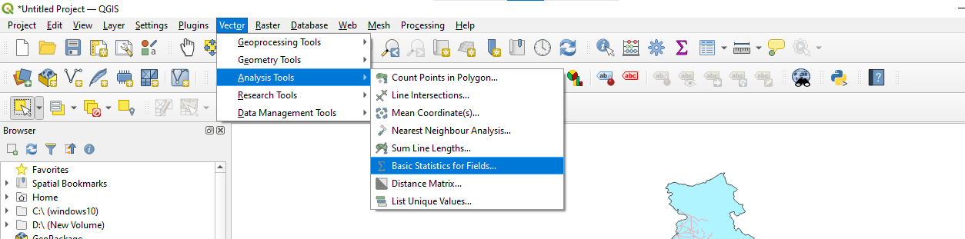

Open Basic Statistics for fields > select Input layer : IND_rails.shp > Set Field to calculate statistics on : Trak_len > Save as and give name in html format > Run

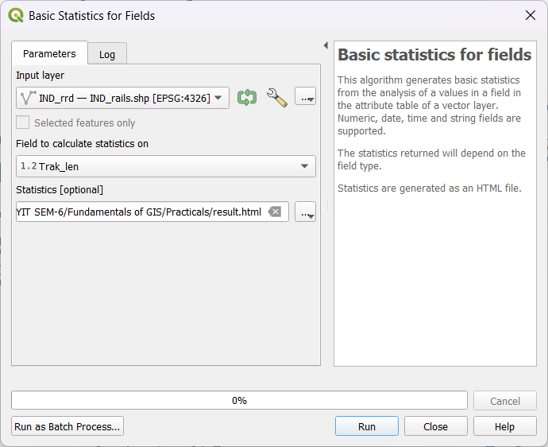

Output of log content > Click Close >

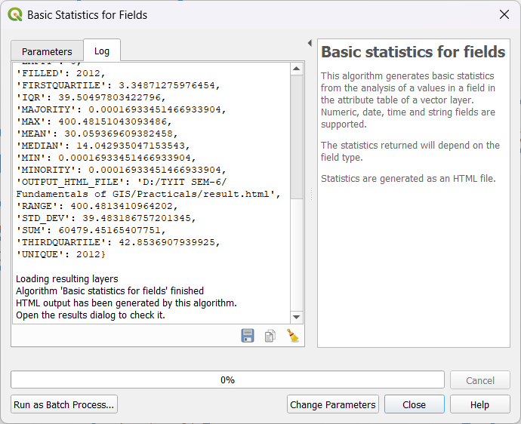

Line lengths and statistics :

